User Guide

April 2018

Version 1.0

Jessica Fritschle, Jeremy Worthy, Ellis Hunter, Michael Goetschius, Abimbola Otugalu

Copyright and third-party information as required

Document Revisions

|  |  |  |
| --- | --- | --- |
| Date | Version Number | Document Changes |
| 03/30/2018 | 1.0 | Initial Draft |
|  |  |  |
|  |  |  |
|  |  |  |
|  |  |  |
|  |  |  |
|  |  |  |
|  |  |  |
|  |  |  |

Table of Contents

1 Introduction 4

1.1 Scope and Purpose 4

1.2 Process Overview 4

2 Process 6

2.1 Install Application / Missing Software 6

2.1.1 [Procedures for Step 1] Example: To Log in to Connect: 6

2.1.2 [Procedures for Step 2]: 7

2.2 [Sub-Process or Workflow Step 2] Example: Asset Record Statuses 7

3 Appendices 9

4 Index 10

# Introduction

## Scope and Purpose

DB2 is a generic inventory tracking application that will allow business managers and owners to track items in stock, orders, sales, customer information, and other relevant information. The application has enhanced search/reporting functionality as well as a threshold alerting system.

This guide assumes that user has no prior knowledge of database management and functionality. All features and usage of the application are explained in a detailed format.

## Process Overview

1. Install Application
2. Create or Load Tables
3. Set Alert Functionality
4. Searching Tables
5. Generating Reports

# [Process]

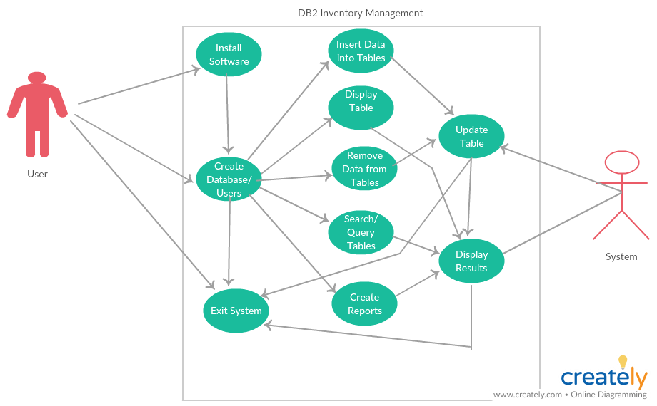

## Installation:

MySQL:

1. Download software from <https://dev.mysql.com/downloads/>
2. Unzip the package.
3. Run the setup.exe file.
4. Everything should be installed in C:\mysql
5. Click Windows start icon 
6. Type run in the search bar and hit enter
7. The window below opens up, click ok if cmd is already there if not type cmd and click ok.

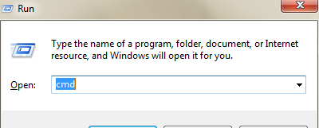

1. Type cd C:\mysql\bin then press enter key
2. Type mysqld.exe –console then press enter key
3. Startup message should appear. You are connected.

Java IDE:

.

### [Install Application]

1. Do something.
2. Complete an action.
3. Select a value.

Screen capture

1. Enter some text.
2. Drag and drop a value.
3. Click or press something to complete the procedure.

**Notes, Cautions or Warnings need to go here:**

### [Create User]:

1. Steps to create administrator and users for mysql go here and screen shots
2. Do the first thing
3. When something happens, do the next thing.
4. Click a button or a link.
5. Enter some data.
6. Complete the action.
7. Complete an action using one of the following options:

* Option 1

1. Click somewhere.
2. Enter something.

* Option 2

1. Click somewhere.
2. Enter something.
3. Select a value.

Screen capture

1. Enter some text.
2. Click or press something to complete the procedure.

## [Create or Load Tables] The following tables come standard with the DB2 Inventory Management Application

|  |  |
| --- | --- |
| Table | Description |
| Items | Stores information about items available in inventory such as quantity and vendor. |
| SalesDetails | Stores actual items per sale |
| Sales | Stores basic information about sales to customers |
| OrdersDetails | Stores actual items ordered per order |
| Orders | Stores basic information about orders made to ventors such as items ordered, date, and quantity |
| Customers | Stores information about customers such as contact information |
| Vendors | Stores information on vendors such as name, poc, and contact info |
| Invoices | Stores information about invoice details such as invoice number, order number, and date |
| Payments | Stores payment information to vendors (invoice number, vendor id, bill total, bill balance. |

## Create Alert Functionality

Here we show how to set thresholds for alerts such as item out, item low, items expiring.

### Item Out

### Item Low

### Item Expiring

## Searching Tables

## Creating Reports

# Appendices

[Appendices are optional, and are used to provide additional detailed information that may help the end user manage the overall application. Examples could include references to standards (such as W3C standards), technical specifications required for regulatory compliance, checklists, or other information of a technical nature.]